High Level Design (HLD)

Revision 0.23

UWC <Product Version #>

High Level Design

<Name of the kit/ Customer name, if any>

Mar 2021 (Draft)

Approvals

<This section is optional. This section can be used for Customer Collateral. Indicate the stakeholders who have approval authority for this document. Typcially that list should include: Receiving Project’s engineering manager, developing group’s engineering manager, and IXA Reuse Tech Oversight chairperson.>

| Role | Name | Signature | Date |
| --- | --- | --- | --- |
|  |  |  |  |
|  |  |  |  |

INFORMATION IN THIS DOCUMENT IS PROVIDED IN CONNECTION WITH INTEL® PRODUCTS AND SERVICES. EXCEPT AS PROVIDED IN INTEL’S TERMS AND CONDITIONS OF SALE FOR SUCH PRODUCTS AND SERVICES, INTEL ASSUMES NO LIABILITY WHATSOEVER, AND INTEL DISCLAIMS ANY EXPRESS OR IMPLIED WARRANTY, RELATING TO SALE AND/OR USE OF INTEL PRODUCTS, AND SERVICES, INCLUDING LIABILITY OR WARRANTIES RELATING TO FITNESS FOR A PARTICULAR PURPOSE, MERCHANTABILITY, OR INFRINGEMENT OF ANY PATENT, COPYRIGHT, OR OTHER INTELLECTUAL PROPERTY RIGHT.

Intel Corporation may have patents or pending patent applications, trademarks, copyrights, or other intellectual property rights that relate to the presented subject matter. The furnishing of documents and other materials and information does not provide any license, express or implied, by estoppel or otherwise, to any such patents, trademarks, copyrights, or other intellectual property rights.

Intel products are not intended for use in medical, life saving, life sustaining, critical control or safety systems, or in nuclear facility applications.

Intel may make changes to specifications and product descriptions at any time, without notice.  
<Include the following text enclosed in curly braces for example designs, interim micro blocks, and   
pre-release/ preliminary documents:>

**{**This document contains information on products and services in the design phase of development. The information here is subject to change without notice. Do not finalize a design with this information.**}**

<Include the following for IA processors, chipsets, and specification updates, if applicable:>

**{**The <product name> may contain design defects or errors known as errata, which may cause the product to deviate from published specifications. Current characterized errata are available on request.**}**

*Third Party trademarks are the property of their respective owners.

Unless otherwise agreed by Intel in writing, you may not remove or alter this notice or any other notice embedded in Materials by Intel or Intel’s suppliers or licensors in any way.

This High Level Design and the software described in it are furnished under license and may only be used or copied in accordance with the terms of the license. The information in this document is furnished for informational use only, is subject to change without notice, and should not be construed as a commitment by Intel Corporation. Intel Corporation assumes no responsibility or liability for any errors or inaccuracies that may appear in this document or any software that may be provided in association with this document. Except as permitted by such license, no part of this document may be reproduced, stored in a retrieval system, or transmitted in any form or by any means without the express written consent of Intel Corporation.

* Other brands and names are the property of their respective owners.

Copyright © 2021, Intel Corporation. All Rights Reserved.

Contents

1 Introduction 11

1.1 Purpose and Scope of this Document 11

1.2 Terminology 11

1.3 Reference Documents 11

2 Detailed Requirements Correlation 13

3 Assumptions, Dependencies, and Risks 14

3.1 Assumptions 14

3.2 Dependencies 14

3.3 Risks and Open Issues 14

4 UWC 15

4.1 System Overview 15

4.2 UWC S/W Block Diagram 16

4.3 Important Terms 17

5 Platform Design 19

5.1 Platform Overview 19

5.1.1 Platform SW Architecture 19

5.2 Considerations for real time processing 19

5.2.1 System Operations 21

5.2.2 Building blocks 21

5.3 System Design 22

5.3.1 Polling Operation 22

5.3.2 On-Demand Read and Write Operations 24

5.3.3 Sequence diagram for operations 25

5.3.4 Timing Measurement 26

5.4 Modbus TCP/RTU Container Application 27

5.4.1 Reading configuration files 27

5.4.2 On demand operations 28

5.4.3 Polling operation 28

5.4.4 Response processing in application 28

5.4.5 Processing within Modbus Stack (master) 28

5.5 MQTT Export Container 32

5.5.1 Design 32

5.5.2 Block Diagram 32

5.5.3 On demand operations 33

5.5.4 Polling operation 33

5.6 Threads and Scheduler 33

5.7 Timer for polling 37

5.7.1 Considerations 37

5.7.2 Design 37

5.8 SADA-RTU Container 41

5.8.1 Purpose 42

5.8.2 SparkPlug Payload Types 42

5.8.3 SparkPlug MQTT Topic 43

5.8.4 SparkPlug Message Mapping 43

5.8.5 Design 47

5.9 KPI App Container 55

5.9.1 Design 56

5.9.2 Block Diagram 56

5.9.3 Control Loop Operation 58

5.10 Common Library 59

5.10.1 Design 59

5.11 Message formats 60

5.12 Key Design Decisions and Alternatives 60

5.12.1 Design Alternative <1, 2, …> 60

5.12.2 Open Issues or Unresolved Trade-off Decisions 61

5.13 Project Configuration Parameters 61

5.13.1 Configuration Options 61

Figures

Figure 1: Block Diagram (Ref: Proposal document) 13

Figure 2: System Overview 15

Figure 3: UWC s/w block diagram 16

Figure 4: Architecture with MQTT and SCADA-RTU Support 19

Figure 5: Polling operation - TCP 23

Figure 6: Polling operation - RTU 23

Figure 7: On-Demand operation - TCP 24

Figure 8: On-Demand operation - RTU 25

Figure 9: Generic sequence diagram flow 26

Figure 10: Timing Measurement 27

Figure 11: Modbus TCP Stack Init Seq diagram 29

Figure 12: Modbus TCP Request Init Seq diagram 30

Figure 13: Modbus RTU Stack Init Seq diagram 31

Figure 14: Modbus RTU Request Init Seq diagram 31

Figure 15: MQTT Export Block diagram 33

Figure 16: Class diagram for timer mechanism 41

Figure 17: SCAD-RTU High Level Flow 42

Figure 18: SCAD-RTU Block Diagram 48

Figure 19: SCAD-RTU Operation Processing: Internals 50

Figure 20: Class diagram SCADA-RTU 53

Figure 21: Sequence diagram – KPI App – ZMQ communication 57

Figure 22: Sequence diagram - KPI App – MQTT communication 57

Figure 23: Block diagram – KPI App – ZMQ communication 58

Figure 24: Block diagram – KPI App – ZMQ communication 58

Tables

Table 1: List of terms 11

Table 2: Reference Documents 11

Table 3: Assumptions 14

Table 4: Dependencies 14

Table 5: Thread Priority 34

Table 6: Classes: Timer design 39

Table 7: Supported SparkPlug Message Details 43

Table 8: SCADA-RTU Actions on connection lost 50

Table 9: Classes: SCADA-RTU Design 53

Table 10: Classes: Common Library 59

Revision History

| Revision | Description | Date | Author |
| --- | --- | --- | --- |
| 0.1 | First draft | 14-Nov-2019 | Softdel |
| 0.2 | Second draft | 29-Nov-2019 | Softdel |
| 0.3 | Third draft | 13-Dec-2019 | Softdel |
| 0.4 | Fourth draft | 24-Jan-2020 | Softdel |
| 0.5 | Fifth draft | 20-Feb-2020 | Softdel |
| 0.6a | Work in progress draft | 03-Mar-2020 | Softdel |
| 0.8 | Added RT design and response handdling | 19-Mar-2020 | Softdel |
| 0.9 | Updated various operation flows based on discussion | 04-Apr-2020 | Softdel |
| 0.10 | Added information about timer mechanism (section 5.7)  Updated as per new TCP stack design | 24-Apr-2020 | Softdel |
| 0.11 | Addressed Dean’s review comments  Added a class diagram | 06-May-2020 | Softdel |
| 0.12 | Added introduction for SCADA-RTU  Udpated stack design for combining RTU containers | 16-Jun-2020 | Softdel |
| 0.13 | Added data for SCADA-RTU | 25-Jun-2020 | Softdel |
| 0.14 | Added data for SCADA-RTU | 07-Sep-2020 | Softdel |
| 0.15 | Added data for SCADA-RTU | 21-Sep-2020 | Softdel |
| 0.16 | Added details for SCADA-RTU | 05-Oct-2020 | Softdel |
| 0.17 | Added details about KPI application and common library | 19-Oct-2020 | Softdel |
| 0.18 | Added details about common library | 02-Nov-2020 | Softdel |
| 0.19 | Added more details | 27-Nov-2020 | Softdel |
| 0.21 | Added more details | 22-Dec-2020 | Softdel |
| 0.22 | Added details about Sparkplug template definition handling | 01-Mar-2021 | Softdel |
| 0.23 | Added NCMD handlig | 22-Mar-2021 | Softdel |

# Introduction

Intel’s IoTG Intelligent Solutions Group (ISG) wants to build a reference design for gateway platform (software + hardware) for Universal Wellhead and Wellpad Controller (UWC) for Oil and Gas (O&G) industry.

Solution is targeted to address multiple pain areas O&G industry is facing in day-to-day operations. These pain areas are further restricting O&G industry to get benefitted from technology advancements resulting from cloud-based services and applications for business intelligence (BI), analytics, dashboards, etc. There is a need to provide a uniform mechanism to connect, monitor and control various devices in an O&G well-site adhering to real-time nature of the industry.

The Intel® UWC is a reference design for a secured management platform that gives third party application developers an easy access to data from O&G well-site.

## Purpose and Scope of this Document

This document explains design of various modules developed for UWC platform.

## Terminology

Table 1 lists the terms used in this document.

Table 1: List of terms

| Term | Description |
| --- | --- |
| SAS | Software Architecture Specification |
| UWC | Universal Wellpad (or Wellhead) Controller |
| EIS | Edges Insights Softwae |
| TC | Turtle Creek |
| OEM/ODM | Original Equipment Manufacturer / Original Design Manufacturer |
| O&G | Oil and gas |
| ISG | IoTG Intelliegent Solution Group |
| BI | Business Intelliegence |
| SCADA | Supervisory control and data acquisition |

## Reference Documents

Table 2: Reference Documents

| Ref | Document Name | Version | File/Location |
| --- | --- | --- | --- |
| [SAS] | <Project Code Name> *SAS* | + | <Insert hyperlink to location here.> |
| [PRD] | <Project Code Name> *PRD* | + | <Insert hyperlink to location here.> |
|  | SparkPlug reference |  | <https://www.eclipse.org/tahu/spec/Sparkplug%20Topic%20Namespace%20and%20State%20ManagementV2.2-with%20appendix%20B%20format%20-%20Eclipse.pdf> |
|  | SCADA-RTU Flows.xlsx | V0.8 |  |
|  |  |  |  |

# Detailed Requirements Correlation

Advancements in drilling operations in the O&G segment have spurred the evolution of complex multi-well pads from simplistic single-well pad fields. Higher data and control requirements are driving the need for a modular, scalable control architecture.

At present, O&G industry is facing certain challenges while in modernizing their existing fields. Examples of these challenges are – devices are not interoperable, difficulty in determining how to get data from current devices and processes, difficulty in maintaining legacy hardware due to availability of parts, security vulnerabilities in current legacy devices, etc.

Intel plans to develop a gateway platform to address above mentioned pain areas thereby providing benefits to O&G industry such as – elimination of vendor lock-in, reduce automation costs, reduce complexity in deployment and maintenance of the solution, increase flexibility (i.e. modularity) and scalability, increase speed of innovation, etc.

Intel plans to achieve above mentioned objectives by decoupling hardware from software, using open architecture, using docker container, modular and incremental development approach, following Intel’s processes and guidelines (for – security, performance, architecture, development, testing and documentation).

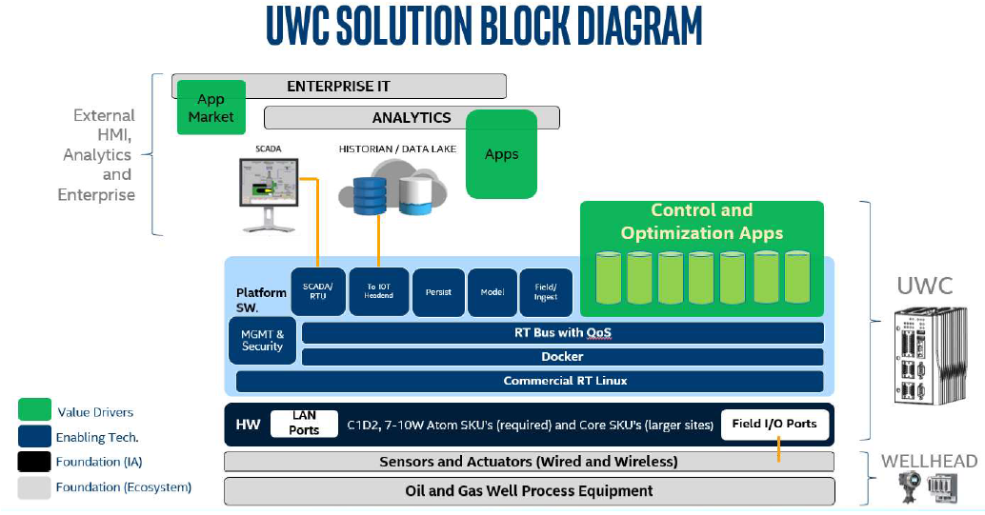

Figure 1: Block Diagram (Ref: Proposal document)

# Assumptions, Dependencies, and Risks

## Assumptions

To be updated.

Table 3: Assumptions

| Assumption # | Assumption Name | Detailed Description |
| --- | --- | --- |
| < # > | < Assumption 1> | < Description 1 > |

## Dependencies

To be updated.

Table 4: Dependencies

| Dependency # | Dependency Name | Detailed Description |
| --- | --- | --- |
| < # > | < Dependency 1> | < Description 1 > |

## Risks and Open Issues

To be updated.

# UWC

## System Overview

The UWC is one of a few initiatives where Oil and Gas industries are working to modernize and IOT-enable their Infrastructure.



Figure 2: System Overview

## UWC S/W Block Diagram

The objective of the proposed system is to develop a dynamically configurable solution which is compatible with the target deployment environment and communicates with field devices using Modbus protocols (Modbus TCP and Modbus RTU). A common data model (i.e. message format) will be defined to expose platform accessible to client applications. The platform should meet the real time requirement i.e. control loop execution.

The platform should also provide an ability to expose the system to SCADA Master over Modbus TCP.

The platform can also be updated (i.e. component update or configuration update) whenever needed locally.

The platform also provides in interface for SCADA Master using Eclipse Foundation’s SparkPlug standard. The SCADA-RTU module implements this interface.

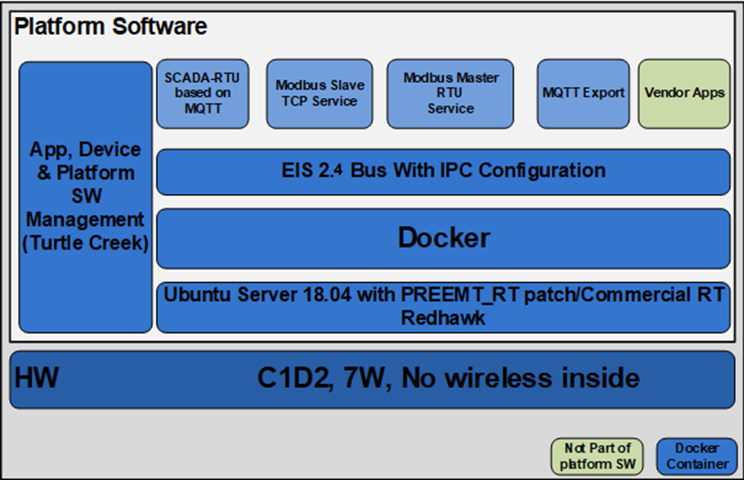

Figure 3: UWC s/w block diagram

## Important Terms

Following terms are used throughout this document:

**Modbus point** or **Data point** or **point**: It is generically used to denote a Modbus register, coil, etc. present in a Modbus slave.

**RT**: It means realtime operation.

**Non-RT**: It means “non realtime” or “normal priority” operation

**Polling interval**: It means an interval (defined in milliseconds) at which Modbus application container will read data from Modbus points. Polling intervals will be decided by platform user and mentioned in data-points configuration file. Example values for field trial are 250, 500, 1000, etc

**Cutoff interval**: This interval is in milliseconds and it is associated with every polling interval. It is defined in terms of certain fraction of polling interval, say 90%. Hence, if polling interval is 500 msec, then associated cutoff interval at 90% is 450 msec. Modbus application container will publish a dummy error response at cutoff interval if no response is received from protocol stack for a request sent at polling interval.

**Cutoff interval percentage**: It is the “fraction” used to calculate cutoff interval. Default is 90%.

# Platform Design

This section describes various modules of the system. These are mainly Modbus containers, MQTT-Export and SCADA-RTU. There is a specific requirement with respect to realtime behavior of the system. Modbus and MQTT-Export modules fall under realtime path. SCADA-RTU does not fall under realtime path.

Next sections describe modules concerned with realtime path. Section 5.8 describes SCADA-RTU module.

## Platform Overview

This section describes various modules of the system.

### Platform SW Architecture

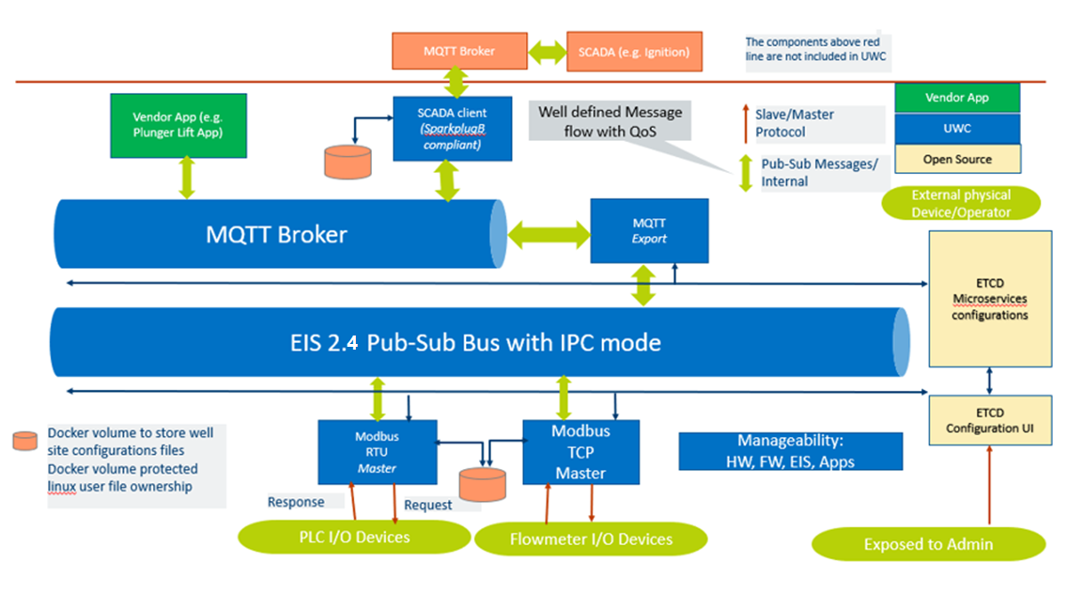

Figure 4: Architecture with MQTT and SCADA-RTU Support

## Considerations for real time processing

Considering need of oil and gas applications, it is decided to provide soft realtime environment. Hence Ubuntu OS with RT patch will be applied. The next sections describe the design of individual containers (i.e. functional blocks) of UWC platform.

This section explains the overall design thought process.

Following are considerations:

1. At present, only Modbus and MQTT-Export modules come under realtime consideration. SCADA-RTU does not come under realtime path.
2. How to decide RT path:
   1. JSON payload for on-demand read and write requests will have a field called “realtime” which denotes whether the request to be executed in realtime mode. Based on this field, RT or Non-RT path for request and response for that instance will be decided.
   2. For polling, datapoints YML will contain a field called “realtime”. Based on this field, RT or Non-RT path for polling of that point will be decided.
3. On ZMQ, different generic topics will be used for RT and Non-RT flow. E.g. “RTPolledData” and “PolledData”.
4. For MQTT,
   1. Topic names are point specific
   2. Topic name will not denote RT or Non-RT differentiation
5. RT and non-RT paths will merge at Modbus stack level. Within Modbus stack, priority queue will be used to prioritize RT processing of different operations.
6. “Good” response will be sent once available.
7. If a response is not received within cutoff interval, then last known response will be sent if available along with bad status.
8. For every request sent to an external Modbus device, a response timeout period will be associated. This response timeout will be configurable at container level. Protocol stack will track response timeout period.
9. In case of response timeout scenario, the protocol stack will inform application container. In such a scenario, request may be retried by the application container. This retry-count will be configurable. The retry will be configurable at operation level and application container will perform the retry after receiving a response timeout notification from protocol tack.
10. No request will be discarded from stack, if a request cannot be sent within polling interval. At the time of sending a new request at next polling interval, if response for previously sent polling request is not received, then application:
    1. will not initiate a new request
    2. publish a bad response with last known good value
11. There will be a generic setting at MQTT Export level which defines “QoS” value to be used for different operations when publishing a message on MQTT.
12. IPC mode of ZMQ will be used for all message communication over ZMQ.

### System Operations

UWC as a platform supports following operations. In general, there is a priority associated with these functions which further guides the system to pick up a task to execute when there are number of tasks.

1. On demand write request: Application can send a write request to a Modbus point.
2. On demand read request: Application can send a read request to a Modbus point.
3. RT data polling: UWC platform will give higher priority to these Modbus points while collecting data at set interval.
4. Normal data polling: UWC platform will poll these Modbus points as per set interval.

Priority of these operations is configurable. These priorities define thread priorities in RT and Non-RT flows and priority of messages in priority queue in Modbus stack.

#### Configuration

Following will be configurable for these operations:

Default realtime behavior

Following will be configurable for each realtime and non-realtime type of operations:

* QOS: MQTT-Export will use this to publish on MQTT
* Operation priority: Defines priority of said operation among all operations.
* Retries: Defines number of times a request to be retried on Modbus network sent if no response is received.

### Building blocks

Following are building blocks of the design:

1. RT patch: To meet timing requirement, it is recommended to use RT patch on Ubuntu OS.
   1. Scheduler: RT patch allows to select a realtime scheduler.
   2. Priority of threads: There are number of threads in the system executing some unique tasks. A priority should be assigned to these threads for execution considering the overall context of the system and priority of operations.
2. Priority of a message: This will be used inside Modbus stack to prioritize message execution.

## System Design

This section describes flows for operations through different containers. Different ZMQ topics are considered for RT and Non-RT. Hence, with this approach, there will be two generic ZMQ topics for one operation like “PolledData” or “PolledDataRT”.

This helps to separate RT/Non-RT paths.

Modbus container will publish on following topics:

1. Polled data
2. On demand write response
3. On demand read response
4. RT Polled data
5. RT On demand write response
6. RT On demand read response

Similarly, MQTT-Export container will publish on following topics:

1. On demand write request
2. On demand read request
3. RT On demand write request
4. RT On demand read request

Subscriber application will have to create corresponding listener threads for these ZMQ topics. Hence, each Modbus container needs to create 4 listeners to receive on-demand read/write RT/Non-RT requests.

MQTT-Export needs to create 6 listeners (On-demand read/write RT/Non-RT response and polling data RT/Non-RT) for each Modbus container.

Following diagram shows system level flow for these operations. These diagrams focus on application-level flows.

### Polling Operation

Following is end-to-end flow for Polling operation. First diagram is for TCP communication and later one is for RTU communication.

Legends in following diagram:

* Polling operation – RT flow
* Polling operation – Non-RT flow

In following diagram, the timer thread from Modbus application, identifies queue to be used based presence of “realtime” field in data point YML configuration file for given point being polled at set interval.



Figure 5: Polling operation - TCP



Figure 6: Polling operation - RTU

### On-Demand Read and Write Operations

Following is end-to-end flow for On-Demand request (read/write) operation. First diagram is for TCP communication and later one is for RTU communication.

Legends in following diagram:

* On-Demand Write – RT flow
* On-Demand Write – Non-RT flow
* On-Demand Read – RT flow
* On-Demand Read – Non-RT flow

In following diagrams, MQTT listener (i.e. subscriber) in MQTT-Export, identifies queue to be used based on topic name (i.e. read or write) and presence of “realtime” field in JSON payload.



Figure 7: On-Demand operation - TCP



Figure 8: On-Demand operation - RTU

### Sequence diagram for operations

Following image depicts how communication is initiated by various modules. Please note in following diagram “Application” can be any application developed on top of UWC. Modbus device is any TCP or RTU device present in network.

The diagram shows how on-demand operation and on-demand-write operation can be performed provided all configurations are proper.

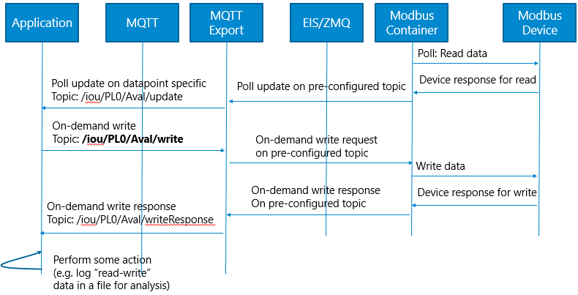

Figure 9: Generic sequence diagram flow

### Timing Measurement

At various level, timestamps are captured so that inter-module data transition time can be measured. Following diagram shows how these timestamps are measured.

Description of these timestamps is available in user guide.

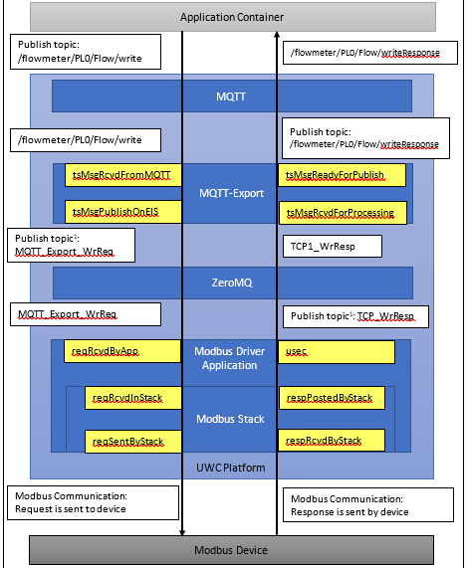

Figure 10: Timing Measurement

## Modbus TCP/RTU Container Application

Modbus TCP/RTU container application listens to ZMQ to receive on-demand read/write requests. The application also performs data polling operation as per configured interval and publishes data to ZMQ. The application also publishes response of on-demand request over ZMQ.

Modbus TCP/RTU container application gets information about Modbus slave devices, points, wellsite, etc. from YML configuration files. Modbus container then sets required contexts, listeners, data structures, etc. needed for performing on-demand and polling operations (RT and Non-RT).

At present, Modbus TCP application and Modbus RTU application are handled in different independent containers.

Further, there can be multiple images of these containers. There is a separate Modbus RTU container or each Modbus RTU communication port. Similarly, note that there could be multiple Modbus TCP application containers.

### Reading configuration files

On startup, Modbus TCP/RTU container application parses YML configuration files which are having global configuration, well sites, device and device data points configuration information. This parsed information is updated into data structures

YAML parser is a 3rd party library. YML files are stored in a data volume mounted in a container.

### On demand operations

For on-demand requests, the application listens on different EII contexts in separate threads for RT and Non-RT flows. Hence there are 4 threads – one RT and Non-RT thread each for on demand write and another for on demand read.

These threads process a received request and send it to stack for further processing.

A priority is assigned to a message based on global configuration for that operation type.

### Polling operation

Polling operation is classified into polling for RT points and polling for non-RT points. For these, separate queue and separate threads are maintained to initiate requests.

There is a timer thread which identifies points to be polled at any given time.

RT/Non-RT polling threads process the received request and sends it to stack for further processing.

A priority is assigned to a message based on global configuration and polling frequency.

### Response processing in application

Stack sends received responses to application. These responses are stored in different queues based on operation type. There is a thread listening on each queue which processes responses. Finally, a JSON is published over ZMQ.

### Processing within Modbus Stack (master)

#### Processing within TCP Stack

Processing within stack is based on priority. For each device, a separate session thread is maintained which takes care of next priority message to execute and manages socket connection for that device. Each device session thread is independent of each other and hence polling requests for multiple devices will happen independently. In such a case, a sequence at which requests are initiated, for given polling interval for multi-device scenario, may vary.

These session threads are created explicitly at the beginning as a part of configuration. A context is associated with each device-specific session thread. The application uses this context while sending a request to a specific device.

For responses, after receiving raw data for a complete response, the associated request and priority are identified. Finally, the matched response is passed to a response dispatcher thread through a priority queue to post the response to application.

A response timeout tracker thread keeps track of time counting. A response timeout action thread checks whether for current time counter, a timeout response needs to be initiated for earlier sent requests.

##### Sequence Diagrams For TCP

Above section explained the use of various threads. This section explains when these threads are created. In following diagrams, for better understanding, “Modbus stack APIs” is shown as an independent entity.

###### Stack initialization

On calling stack init API, at the beginning various threads are created. Please note device specific session thread is not created. This thread will be created when API to get new context is executed by application.

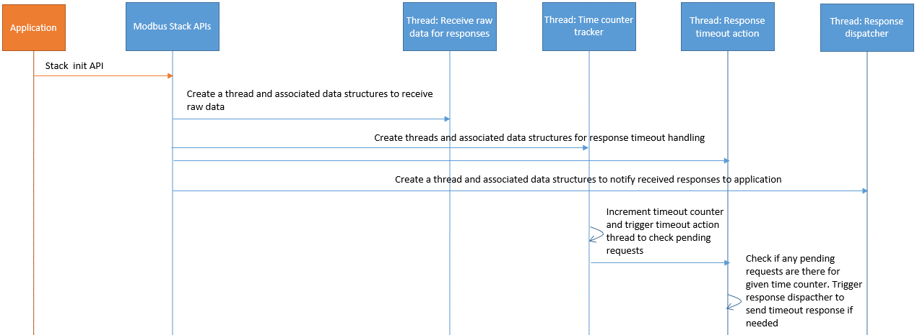

Figure 11: Modbus TCP Stack Init Seq diagram

###### Getting device context and request processing

Following diagram shows device specific session creation and then request processing.

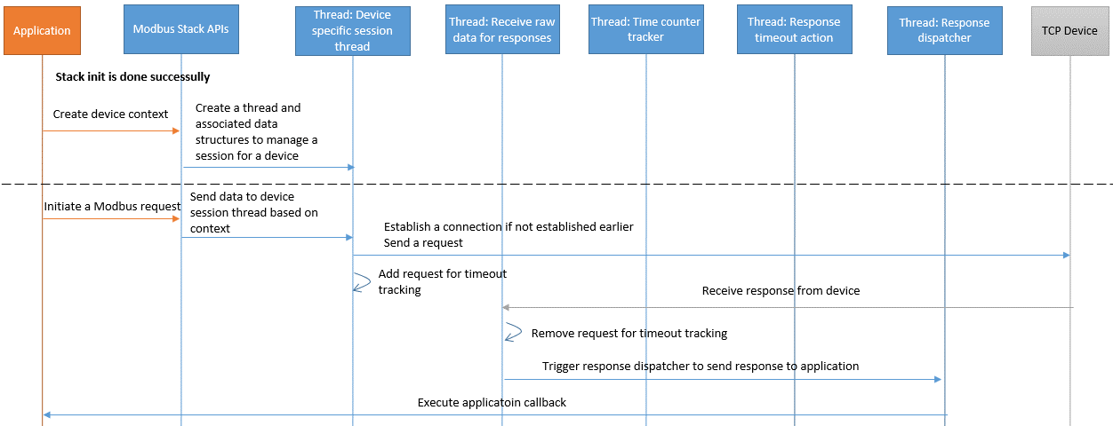

Figure 12: Modbus TCP Request Init Seq diagram

In case of timeout, no response will be received from device. On timeout completion, timeout action thread will trigger response dispatcher thread to send timeout response.

#### Processing within RTU Stack

In case of Modbus RTU only one request can be sent on one Modbus RTU network at one time and next request cannot be sent unless a response is received, or a timeout occurs. A priority queue is used to decide request to be processed. Response, once received, is passed to a response dispatcher thread through a priority queue to post the response to application.

Communication with multiple RTU networks can be maintained at any given time. A separate thread is created for each different RTU network. Each RTU network communication thread is independent of each other and hence polling requests for multiple devices will happen independently. In such a case, a sequence at which requests are initiated, for given polling interval for multi-RTU-network scenario, may vary.

##### Sequence Diagrams For RTU

Above section explained the use of various threads. This section explains when these threads are created. In following diagrams, for better understanding, “Modbus stack APIs” is shown as an independent entity.

###### Stack initialization

On calling stack init API, at the beginning various threads are created. Please note RTU network specific session thread is not created. This thread will be created when API to get new context is executed by application.

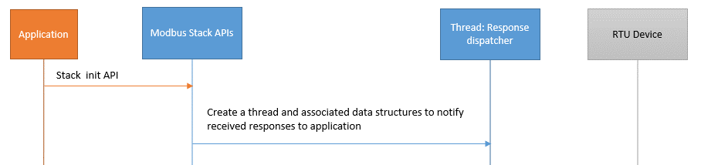

Figure 13: Modbus RTU Stack Init Seq diagram

###### Getting device context and request processing

Following diagram shows RTU network specific session creation and then request processing.

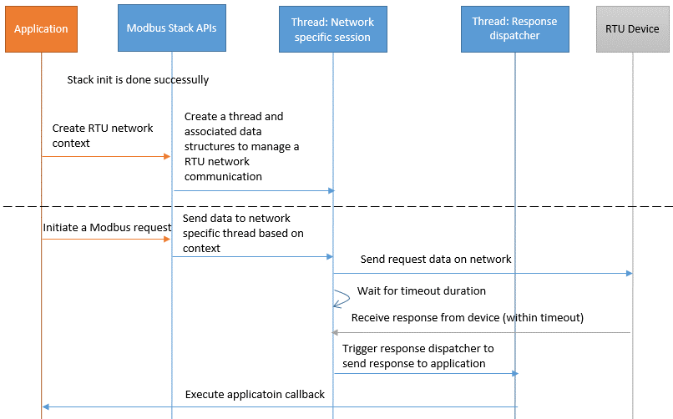

Figure 14: Modbus RTU Request Init Seq diagram

In case of timeout, no response will be received from device. On timeout completion, response dispatcher thread will be triggered to send timeout response.

## MQTT Export Container

MQTT Export container application listens to MQTT to receive on-demand read/write requests. The application listens to ZMQ to receive polling data and response of on-demand requests. The application sends data from MQTT to ZMQ and vice versa.

### Design

MQTT Export container application sets required contexts, listeners, MQTT subscriber and listener, etc. needed for sending data to and fro for both ZMQ and MQTT.

Topic to be used for publishing data on MQTT is mentioned in a message received from ZMQ.

Separate generic topics are used to publish data on ZMQ for on-demand requests for RT and Non-RT.

MQTT Export listens to RT and Non-RT topics from all Modbus containers.

MQTT-Export reads global configuration at the start up to define the operation and thread priority.

### Block Diagram

The MQTT client uses port 11883 (secure port) for MQTT communication. For ZMQ IPC is used

For ZMQ to MQTT communication, the MQTT export module receives MQTT topic name as a part of JSON payload. This MQTT topic is used to publish a message on MQTT.

For MQTT to ZMQ communication, the MQTT export module publishes messages on generic topics on EII.



Figure 15: MQTT Export Block diagram

### On demand operations

For on-demand requests, the application listens on MQTT topics, pushes the message on appropriate queue based on topic type (read / write) and message type (RT and Non-RT).

Separate threads are listening on these queues to process the request and to send it to ZMQ using appropriate RT/Non-RT read/write request topic.

Similarly, separate listener threads are created to read data from ZMQ topics to receive responses. These threads process responses and publish it to MQTT. There are separate threads for RT/Non-RT response for read/write.

### Polling operation

Separate listener threads are created to read data from ZMQ topics to receive polling data. These threads process polling data and publish it to MQTT. There are separate threads for RT/Non-RT polling.

## Threads and Scheduler

With RT patch, a different scheduler and priority can be configured for thread processing. This section describes the priorities considered. For SCADA-RTU, threads are executed in normal mode. Following section applies to Modbus and MQTT-Export modules.

Table 5: Thread Priority

Following table shows priorities that can be considered for various threads throughout the system.

Scheduler to be used: RR

|  |  |  |  |  |  |  |  |  |
| --- | --- | --- | --- | --- | --- | --- | --- | --- |
|  | Modbus container | | | MQTT-Export container | | | Priority | Comments |
|  | Module / Thread | Count | Total | Module / Thread | Count | Total |
| RT On-demand write | Req processing | 1 | 2 | Req processing | 1 | 1 + N | 60 | Priority for RT operations: On-demand write > On-demand read > Polling |
| Resp processing | 1 | Resp processing | 1 x Number of Modbus containers (N) |
| RT On-demand read | Req processing | 1 | 2 | Req processing | 1 | 1 + N | 55 |
| Resp processing | 1 | Resp processing | 1 x Number of Modbus containers |
| RT Polling | Req init | 1 | 3 |  |  |  | 50 |
| Resp handling Cutoff handling | 1 1 | Polled data handler | 1 x Number of Modbus containers | N |
| Non-RT On-demand write | Req processing | 1 | 2 | Req processing | 1 | 1 + N | 15 | Priority for Non-RT operations: On-demand write > On-demand read > Polling |
| Resp processing | 1 | Resp processing | 1 x Number of Modbus containers |
| Non-RT On-demand read | Req processing | 1 | 2 | Req processing | 1 | 1 + N | 10 |
| Resp processing | 1 | Resp processing | 1 x Number of Modbus containers |
| Non-RT Polling | Req init | 1 | 3 |  |  |  | 5 |
| Resp handling Cutoff handling | 1 1 | Polled data handler | 1 x Number of Modbus containers | N |
| Timer | Timer thread | 1 | 1 |  |  |  | 65 | Timer tick is given highest priority to ensure polling interval is measured correctly. |
| Modbus RTU stack | RTU communication | 1 x RTU Network count (R) | 1 + R |  |  |  | 30 | Stack operations are given higher priority than Non-RT operations and lower than RT operations |
| Resp dispatcher | 1 |  |  |  |
| Modbus TCP stack | Device session | 1 x TCP device count (M) | 3 + M |  |  |  | 30 | Stack operations are given higher priority than Non-RT operations and lower than RT operations.  We can have a range defined here. E.g. 30-40 |
| Resp dispatcher | 1 |  |  |  |
| Resp timeout tracker | 1 |  |  |  |
| Resp timeout action | 1 |  |  |  |

## Timer for polling

This section describes the mechanism used for implementing a timer needed for polling operation.

### Considerations

There will be number of polling intervals and associated cutoff intervals defined in milli-seconds. Following are considerations:

A different timer for each of polling and cutoff interval, might result in too many timers which need to be monitored. This approach could also lead to having more number of threads.

Looking at above mentioned scenario, a single timer is proposed for overall polling operation.

#### Timer selection

Over the period, following approaches were tried/evaluated for timer for polling operation in Modbus application container. Please note timer operation in each container (e.g. Modbus TCP, Modbus RTU) is independent of each other.

* Timer from boost library: This timer was not accurate and there was some lag in getting tick. This was first used in sprint 1.
* Interrupt based timer: This mechanism gave accurate ticks but for each tick a separate interrupt was generated. Interrupts caused system to become unstable. This was first used in sprint 5.
* usleep based timer: Linux API “usleep” was used to sleep between timer intervals. Sometimes, this mechanism did not give required accuracy. This was used in sprint 9.
* timerfd based timer: This is based on Linux’s timerfd_create() mechanism. A consistency was not observed during testing with this timer. This was used in sprint 11.
* High resolution timer: High resolution timer upto nanosecond precision can be implemented using Linux using APIs “clock_nanosleep()” function. This is implemented in sprint 12.

High resolution timer is selected as it gave consistent and accurate results.

### Design

This section provides details of design for timer.

#### Timer algorithm

Following is a high-level algorithm for timer using high resolution timer:

Step 1: Get current monotonic time (say T1) using clock_gettime()

Step 2: Add interval (say In1) after which function needs to be triggered.

T2 = T1 + In1

Step 3: Use function clock_nanosleep() with monotonic clock and TIMER_ABSTIME flag to sleep till T2 time is reached.

Step 4: After sleep, perform operations related to polling

Step 5: Assign T2 to T1 i.e. T1 = T2

Step 6: Go to step 2.

#### Polling timer algorithm

There will be number of polling intervals and associated cutoff intervals defined in milli-seconds. e.g. 250, 500, 1000, 2000, etc. Polling requests should be initiated at the polling interval.

As presented earlier, a single timer is proposed to handle all different polling and cutoff intervals. Following is a high-level algorithm for this based on a concept of a counter:

Step 1: Calculate greatest common factor (say INTERVAL) of all polling and cutoff intervals. Smallest possible common factor i.e. INTERVAL is 1 msec.

Step 2: Identify the highest value of polling interval (say MAX_INTERVAL)

Step 3: Set counter value for each polling interval assuming counter starts from 0.

E.g. For polling interval of 250, counter value will be 250.

For polling interval of 1000, counter value will be 1000.

Step 4: Set counter tracker (say CTR_TRACKER) to 0.

Step 5: Start timer with sleep-interval as INTERVAL

Step 6: After sleep, increment counter:

CTR_TRACKER = CTR_TRACKER + INTERVAL

Step 7: Check if any of polling interval’s counter value is equal to CTR_TRACKER

Step 7a.1: If yes, trigger request initiation for eligible points

Step 7a.2: Set next counter value by adding polling interval to current counter value.

If counter value for polling interval exceeds MAX_INTERVAL, then roll over.

Step 8: If CTR_TRACKER value exceeds MAX_INTERVAL, then roll over.

Step 9: Go to step 6.

#### Timer design

On a high level, following classes participate in managing polling operation. Other classes are not listed for simplicity.

Table 6: Classes: Timer design

|  |  |
| --- | --- |
| Class name | Description |
| CTimeRecord | This class maintains a list of points to be polled against certain polling interval.  This class maintains following:   * Polling interval * Cutoff interval * List of RT and Non-RT points against the polling interval |
| StPollingTracker | This structure maintains polling interval, reference to CTimeRecord object and next counter to be used for polling. |
| CTimeMapper | This class maintains a list of CTimeRecord objects and tracks polling for these objects.  This class maintains following:   * List of CTimeRecord objects * List of StPollingTracker objects |
| CRequestInitiator | This class maintains threads, data structures to initiate a Modbus request as per polling interval and to send error responses at cutoff interval. This class maintains data for both RT and Non-RT threads and operations.  The class also maintains a data structure to map a response with an initiated polling request. |
| CRefDataForPolling | This class represents a point for which polling is needed. It has following:   * a reference of other class representing actual unique point * last polling status * current polling timestamp * data structure containing Modbus request information * reference of ZMQ context used for publishing data of this point |

Following is a high-level class diagram which depicts the association between these classes. For simplicity, only relevant class members are shown in following diagram.



Figure 16: Class diagram for timer mechanism

## SADA-RTU Container

SCADA-RTU provides an interface to SCADA Master using Eclipse Foundation’s SparkPlug standard. SCADA RTU will publish data over MQTT for SCADA Master. MQTT Topics and Payload standardization is must for SCADA RTU interoperability with multi-vendor SCADA Master.

UWC selected Eclipse Foundation’s Sparkplug B specification for interoperability of SCADA RTU implementation with multi-vendor SCADA Master (e.g., Ignition, Autosol eACM, Wonderware, Cloud based deployments).

SCADA-RTU does not fall under realtime path.

### Purpose

This module exposes the data on the platform to an external, centralized, master system for the SCADA:

* Data from base UWC platform
* Mechanism to expose data from Apps running on UWC

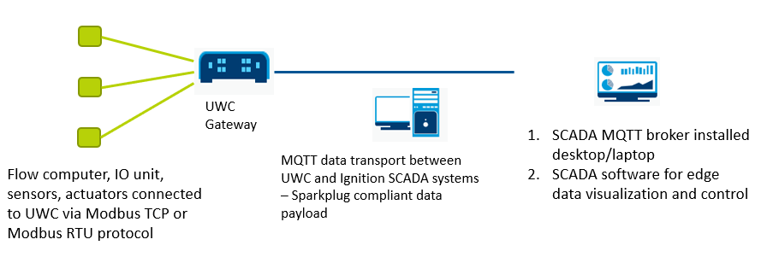

Figure 17: SCAD-RTU High Level Flow

### SparkPlug Payload Types

Following are the payload types defined by SparkPlug standard:

* Edge node birth (NBIRTH)
* Edge node death (NDEATH)
* Device birth (DBIRTH)
* Device death (DDEATH)
* Node data Message (NDATA)
* Node command (NCMD)
* Device data Message (DDATA)
* Device command (DCMD)
* SCADA Master application stat message (STATE)

Refer SparkPlug standard for more information.

### SparkPlug MQTT Topic

Following is the topic format:

spBv1.0/group_id/message_type/edge_node_id/[device_id]

“group_id” and “edge_node_id” are specified under global-configuration. For “edge_node_id”, to make it unique, MAC id of the gateway is appended. If the MAC-id is absent, then a fixed string “00” is used.

Device id is mentioned like “device_id-device_group_id” e.g. iou-PL0.

The value of the “group_id”, “edge_node_id” and “device_id” can be valid UTF-8 alphanumeric string. The string shall not use the reserved characters of ‘+’ (plus), ‘/’ (forward slash), and ‘#’ (number sign).

### SparkPlug Message Mapping

This section details the mapping for currently supported messages (listed below).

Table 7: Supported SparkPlug Message Details

|  |  |  |
| --- | --- | --- |
| Message Type | Support for real device | Support for virtual device (apps) |
| NBIRTH | Supported. This is an edge level message. | |
| NDEATH | Supported. This is an edge level message. | |
| DBIRTH | Supported. Data is taken from YML file. | Supported. Vendor app should publish data on “BIRTH” topic. |
| DDATA | Supported. Data from Poll-update messages is taken to determine change in data for publishing a DDATA message | Supported using RBE (Report By Exception). Vendor app should publish data on “DATA” topic. |
| DCMD | Supported. A corresponding On-Demand-Write request message is published on internal MQTT for other UWC containers to process a request. | Supported. A corresponding CMD message is published on internal MQTT for vendor app. |
| DDEATH | Supported. Data from Poll-update messages is taken to determine change in data for publishing a DDEATH message in case of error scenarios | Supported. Vendor app should publish data on “DEATH” topic. |
| NDATA | Not Supported |  |
| NCMD | Supported for “Node Control/Rebirth” control | |
| STATE | Not Supported | |

#### NBIRTH

This message is published on start-up after establishing a connection with MQTT broker.

1. On start-up, SCADA-RTU reads data about Modbus devices (both TCP and RTU) from YML files.
2. It identifies all datapoints YML files. E.g., iou_datapoints.yml, flowmeter_datapoints.yml, etc.
3. Each YML file corresponds to one SparkPlug template definition.
   1. Name of YML file is used as a name of SparkPlug template.
   2. Version of YML file is used as a version of SparkPlug template.
   3. Protocol type is added as a parameter for this template definition.
   4. Metrics in YML file are used as metrics inside template.
      1. For each of these metrics, following fields from YML file are mapped as properties:
         1. Pollinterval
         2. Realtime

#### NDEATH

This message is published by MQTT broker when a connection with SCADA-RTU is broken. For this to work, a proper Will payload is set by SCADA-RTU while establishing a connection with MQTT broker.

#### DBIRTH

##### DBIRTH for real devices

This message is published on start-up after NBIRTH is sent.

1. On start-up, SCADA-RTU reads data about Modbus devices (both TCP and RTU) from YML files.
2. A DBIRTH message is prepared for each Modbus device and published over MQTT.
3. For a Modbus device, there is one major metric of type template.
   1. A corresponding datapoints YML file is used as a template for a Modbus device definition.
   2. Device id is name of template type metric.
   3. Reference of template is corresponding datapoints YML file.
4. Each datapoint from a device is mapped as a metric inside template in DBIRTH message for respective device.
5. For each of these metrics, following fields from YML file are mapped as properties:
   1. Pollinterval
   2. Realtime

Please note, in current design, when the gateway starts, the SCADA-RTU module publishes DBIRTH messages for Modbus devices with default empty values for metrics. This is a static message published based on data available in YML files.

##### DBIRTH for virtual devices (i.e. Apps)

DBIRTH message is published in following cases when a BIRTH message is received.

1. It is a first BIRTH message for the virtual device.
2. There is a change in metrics reported earlier in 2 BIRTH messages for the virtual device.
3. Previously a DDEATH message is published and then a BIRTH message with no changes is received for the device.

Please refer document “SCADA-RTU Flows.xlsx” for detailed flows.

#### DDATA

##### DDATA for real devices

DDATA message is published in following cases when a polling update message is received for a real device:

1. There is a change in metric value compared to the one reported earlier and there is no error scenario.

Note that SparkPlug template format is used for publishing DDATA message.

##### DDATA for virtual devices (i.e. Apps)

DDATA message is published in following cases when a DATA message is received.

1. There is a change in metric value compared to the one reported earlier in BIRTH or DATA message.

DBIRTH message is published in following cases when a DATA message is received.

1. Previously a DDEATH message is published and then a DATA message is received for the device.

Please refer document “SCADA-RTU Flows.xlsx” for detailed flows.

#### DDEATH

##### DDEATH for real devices

DDATA message is published in following cases when a polling update message is received for a real device having error code:

1. If error code is a specific one which means device is not reachable, then a DDEATH message is published for a rea device.
2. For a real device, once a DDEATH message is published, then device poll updates are monitored to identify a change in state of a device. When a proper data is received, a DBIRTH message is sent for the real device.

##### DDEATH for virtual devices (i.e. Apps)

DDEATH message is published in following cases:

1. When a DEATH message is received for a vendor app
2. When a new BIRTH message is received for a virtual device

Please refer document “SCADA-RTU Flows.xlsx” for detailed flows.

#### TemplateDef

This is a special message used by vendor app to provide definition of a Sparkplug Template i.e., UDT to SCADA-RTU. On receiving this message, SCADA-RTU identifies that a new UDT definition is received. UDT definitions are sent to SCADA master as a part of NBIRTH message. Hence, on receiving UDT definition, the messages are published in the sequence: NDEATH and then NBIRTH.

##### Using UDT in BIRTH message

A metric can be of type UDT. These metrics are published in BIRTH message. The UDT metric should provide reference of UDT which was earlier published using TemplateDef message.

#### START_BIRTH_PROCESS

This is a special message used by SCADA-RTU to inform vendor apps that SCADA-RTU module is functional now. On receiving this message, a vendor app shall send all Sparkplug Template definitions it intends to use, using TemplateDef message. The vendor app shall also send app device details using BIRTH message.

#### NCMD

SCADA master can initiate NCMD message asking for rebirth of node. In this particular case, the node shall publish NBIRTH, DBIRTH messages.

### Design

Following is a high level block diagram.

External MQTT connecting to SCADA Master

SCADA-RTU

MQTT Handler (uses Paho Library)

SparkPlug Standard handler (using Tahu Library)

SCADA-RTU/ EdgeNode functions:

1. Build network info
2. Establish MQTT connection
3. Publish messages

YML Parser

Internal MQTT connecting to vendor apps and MQTT-Export

Figure 18: SCAD-RTU Block Diagram

In terms of SparkPlug, UWC gateway is an edge-node. The SCADA-RTU module implements the SparkPlug standard.

The Tahu library from Eclipse provides APIs required to build SparkPlug data structures, message encoding / decoding, etc. For testing purpose, SparkPlug encoded messages can be viewed in MQTT.Fx, a generic 3rd party MQTT client.

The Paho library is used to publish messages on MQTT broker. Please note this is an external MQTT broker. This is set up by SparkPlug compliant SCADA Master. There could be multiple MQTT brokers. At present, this design only considers one MQTT broker.

SCADA RTU module performs following:

1. Establishes connection with MQTT broker. Configures Will payload such that MQTT broker can publish a proper NDEATH message when a connection is broken.
2. Publishes NBIRTH message.
3. Builds network information using YML file. This information is used to build DBIRTH messages.
4. Publishes DBIRTH message for each Modbus device based on information available in YML file.
5. Subscribes to:
   1. virtual device messages (BIRTH/#, DATA/#, DEATH/#, TemplateDef)
   2. real device poll update messages
6. Publishes START_BIRTH_PROCESS to vendor app.
7. For vendor app (i.e., virtual devices):
   1. Publishes DBIRTH message when appropriate on receiving BIRTH message from app
   2. Publishes DDEATH message when appropriate on receiving DEATH or BIRTH message from app
   3. Publishes DDATA message when appropriate on receiving DATA message from app
8. For real devices:
   1. Publishes a DDATA message when there is a change in value of the metric
   2. Publishes a DDEATH message when an error code meaning “unreachable device” is received
   3. Publishes a DBIRTH message when “unreachable device” changes status to “reachable”

#### Operation Processing

Following is the design approach:

SCADA-RTU

External MQTT connecting to SCADA Master

Thread: To process a message from queue

Queue to store (BIRTH, DATA, DEATH) messages

Internal MQTT connecting to vendor apps and MQTT-Export

Thread: To process a message from queue

A

Queue to store DCMD messages

Figure 19: SCAD-RTU Operation Processing: Internals

Messages from internal MQTT are stored in a queue. There is a thread which listens to this queue and processes messages received from queue to publish data on external MQTT in SparkPlug format.

Similarly, there is a queue which stores data received from external MQTT. These are DCMD messages. There is a thread which listens on this queue and publishes CMD or On-Demand-Write operation.

Please note all messages are processed sequentially from given queue for following reasons:

1. The status of devices to be published depends on the last status published which in turn depends on some other factors. E.g., If last message published was DDEATH, then next message to be published should be DBIRTH.
2. RBE for DDATA should be calculated with respect to last reported value.

MQTT connection handling: Following threads are created to process notifications from MQTT broker. Please note these threads are created for both internal MQTT handler and external MQTT handler:

Table 8: SCADA-RTU Actions on connection lost

|  |  |  |
| --- | --- | --- |
| Notification | Internal MQTT Handler | SCADA MQTT Handler |
| Connection established | * Subscribes to topics * If the connection is established, then a signal is sent to a thread* which publishes DBIRTH message on SCADA-MQTT connection for all up devices | * Subscribes to topics * Publishes NBIRTH and DBITH messages |
| Disconnected | * Monitors for given time (1 min) to see whether a connection is established. * If the connection is not established, then a signal is sent to a thread** which publishes DDEATH messages on SCADA-MQTT connection | - |
| Message received | Above block diagram shows these threads. It processes device update messages. | Above block diagram shows these threads. It processes DCMD messages. |

*There is a separate thread which sends DBIRTH messages for known online devices whenever internal MQTT connection is established.

**There is a separate thread which sends DDEATH messages whenever internal MQTT connection is lost for given timeout.

#### Class Diagram

Following is a conceptual class diagram:



Figure 20: Class diagram SCADA-RTU

Table 9: Classes: SCADA-RTU Design

|  |  |
| --- | --- |
| Class name | Description |
| CSparkPlugDev | This class represents a real Modbus device or a virtual app subclass. It contains a reference to classes derived from YML file parsing. For real Modbus device, it refers CUniqueDataDevice.  This class maintains following:   * List of metrics * Last published device/message status |
| CIfMetric | This class is a base class for a Sparkplug metric of base type or template type. |
| CMetric | This class is derived from CIfMetric and it represents a real Modbus device data-point or a datapoint from a virtual app subclass. It contains a reference to classes derived from YML file parsing. For real Modbus device datapoint, it refers CUniqueDataPoint.  This class maintains following:   * Value * Last timestamp for this property |
| CUDT | This class is derived from CIfMetric and it represents a Sparkplug Template. It represents both – UDT definition and UDT instance. This class implements a composite design pattern.  The class maintains Metric list of UDT. |
| CSparkPlugUDTManager | This class manages UDT definitions. It provides interface to parse UDT definition messages, to access UDT definitions.  This is a singleton class.  This class maintains UDT using 2 primary keys – major key is UDT-name, minor key is UDT version.  These fields are present in TemplateDef message used to define a UDT.  Each UDT instance refers to these fields to uniquely identify UDT definition to be referred. |
| CValObj | This class represents a value of a metric. The value can be of different datatypes.  This class maintains following:   * Datatype * Value as per datatype |
| CVendorApp | This class represents a vendor app. This class contains a list of subclasses represented as CSparkPlugDev. |
| CVendorAppList | This class maintains list of all CVendorApp objects. |
| CSparkPlugDevManager | This class maintains all CSparkPlugDev objects. This class parses all messages received from internal and external MQTT and accordingly updates CSparkPlugDev objects and decides action to be taken. E.g., when a DEATH message is received for a CVendorApp objects, this class identifies that DDEATH message needs to be published for all CSparkPlugDev objects representing subclass associated with that vendor app.  This is a singleton class.  This class also implements a factory method to determine which metric type to create whether base type or template type. |

## KPI App Container

“KPI Application” represents a sample application which is provided to depict how one can develop an application on UWC platform. This is a simple application which demonstrates how “single input, single output” control loop can be implemented.

A control loop is executed continuously to monitor certain parameter and the adjust other parameters. Thus, a control loop consists of one read operation and one write operation. In this sample application, polling mechanism of UWC platform is used to receive values of parameters as per polling interval. The application uses “on-demand-write” operation on receiving data from polling.

This KPI application can either be executed based on MQTT communication or based on ZMQ communication based on communication.

The KPI Application also logs all data received as a part of control loop application in a log file. This data can be used for measuring performance of the system.

### Design

For ZMQ-based communication, the KPI application

1. uses generic topics:
   1. uses RT or Non-RT topics (based on configuration) for getting updates from polling and write responses
   2. uses RT or Non-RT topics (based on configuration) for sending write requests
2. sets required ZMQ contexts, ZMQ listeners, etc.
3. sets value of realtime field in write request payload depending on RT/NON-RT communication

For MQTT-based communication, the KPI application

1. uses point-specific topics
2. sets required MQTT listeners, etc.
3. sets value of realtime field in write request payload depending on RT/NON-RT communication

### Block Diagram

The MQTT client uses port 1883 (non-secure port) for MQTT communication. For ZMQ IPC is used

Flow diagram for ZMQ based communication:

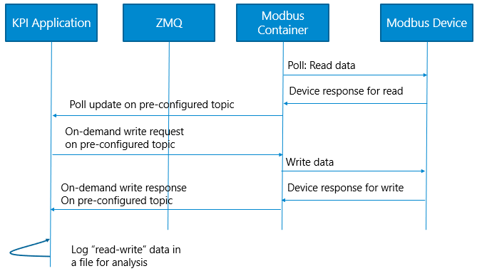

Figure 21: Sequence diagram – KPI App – ZMQ communication

Flow diagram for MQTT based communication:

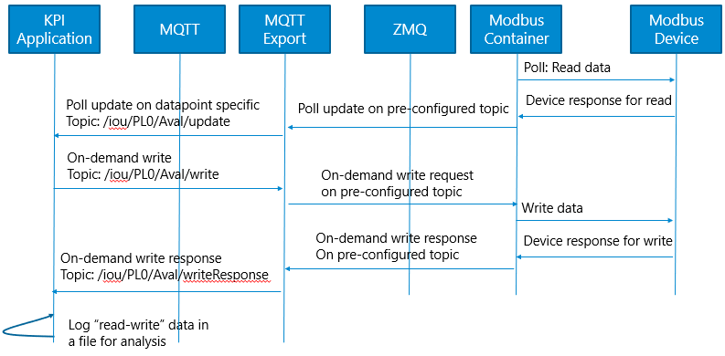

Figure 22: Sequence diagram - KPI App – MQTT communication

Block diagram for ZMQ:

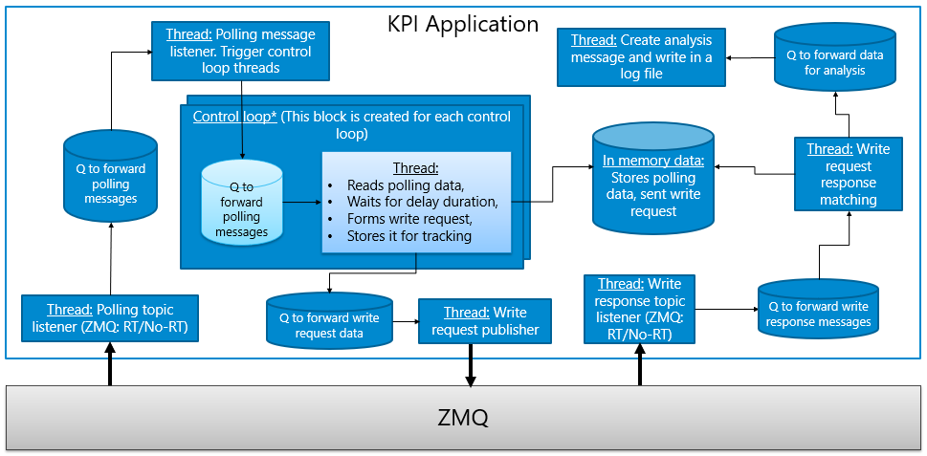

Figure 23: Block diagram – KPI App – ZMQ communication

Block diagram for MQTT:

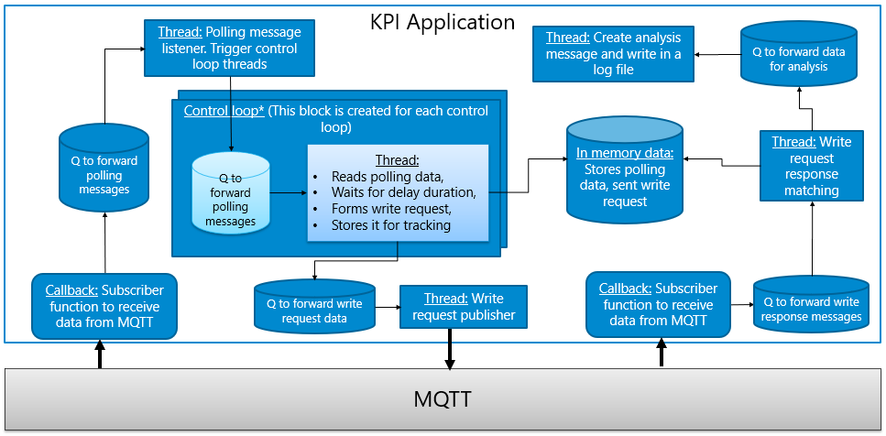

Figure 24: Block diagram – KPI App – ZMQ communication

### Control Loop Operation

In control loop, once a polling data is received, before sending a write request a pre-configured delay needs to be added. For this, a separate thread is created for each control loop. In that thread, once a polled data is received, a write request is created after adding a specific delay. This created request write is sent to another thread to post it to ZMQ or MQTT.

The write request data and associated polling data are stored in a map for creating a log-record once a write response is received.

If new polling data is received before receiving write response of previously initiated write request, then an error is logged.

#### ZMQ based communication

For ZMQ based communication, separate threads are created for each generic topic based on RT or Non-RT configuration on polling data and write response. These threads will store data in queue for further processing.

#### MQTT based communication

For MQTT based communication, callback functions are triggered by MQTT library. These threads will store data in queue for further processing.

#### Thread operations

Control loop operation handling design is independent of ZMQ and MQTT communication.

There is one queue and one thread which receives polling data for all points. This thread posts data to individual control loop handlers.

Each control loop handler has one queue and one thread. The thread performs the operation as described above.

There is one queue and one thread which receives write response data for all points. This thread does request response matching and sends data to another thread for logging into a log file for analysis.

## Common Library

UWC platform contains different containers. These modules perform certain operations which are similar in nature. For this, a common library is built which is used by all modules.

### Design

Following are the details of classes/namespaces present in this common library:

Table 10: Classes: Common Library

|  |  |
| --- | --- |
| Class name | Description |
| CLogger | Implements logging mechanism. It uses log4cpp library. This class is used by all modules to create logging data. |
| network_info | It is a namespace which hold number of classes used to store data parsed from YML files about wellhead, device, datapoint, etc. |
| globalConfig | It is a namespace which holds data about Global_Config.yml file |
| CfgManager | This class is used to store handles of ETCD like config manager and env config |
| CcommonEnvManager | This class is used to store information about dev mode and app name. |
| EnvironmentInfo | This class is used to parse environment variables and store the values. It provides interface to access these environment variables on need basis. |
| CQueueHandler | This class implements a queue to store data and inform others when a data is received. |
| zmq_handler | It is a namespace which contains data structures which are used to store ZMQ related contexts for pub and sub mechanism. |
| CMQTTPubSubClient | It is a class which implements a publisher and subscriber for MQTT |
| CMQTTBaseHandler | It is a base class used to handle callbacks from MQTT. It provides a base framework to operate MQTT handling. This class is then extended by MQTT handlers in different modules. |

## Message formats

Refer user guide for message formats.

## Key Design Decisions and Alternatives

Sample text

### Design Alternative <1, 2, …>

Sample text

### Open Issues or Unresolved Trade-off Decisions

Sample text.

## Project Configuration Parameters

### Configuration Options

Sample text